AI & CAREER NOTES
Unit Topic:
“Pick Your AI Path — Portfolio to Profession”
Prepared for: Undergraduate 2nd Year Students
Subject Area: Artificial Intelligence / Career Foundations
Format: Theory Notes with Diagrams

1. Introduction
Artificial Intelligence (AI) has grown from a specialised research field into one of the largest and fastest-growing employment sectors in the world. For a second-year undergraduate student, this is the ideal stage to begin exploring the discipline seriously — you already have a foundation in programming and mathematics, and you still have two to three years to build real, demonstrable skills before you graduate.
The purpose of these notes is to help you understand the major career paths within AI, the theoretical foundations behind each path, and — most importantly — how to convert classroom learning into a professional portfolio that employers and graduate programmes actually value. This is the journey from ‘Portfolio to Profession.’
- Why this matters now: Recruiters increasingly evaluate AI candidates not just on degree scores but on what they have built, published, or contributed to. A strong, well-documented portfolio is now as important as a strong transcript.

2. The AI Career Landscape
AI is not a single job — it is an umbrella term covering several distinct specialisations, each requiring a different mix of mathematics, programming, and domain knowledge. The diagram below summarises the eight most common entry-level and early-career paths available to an undergraduate.
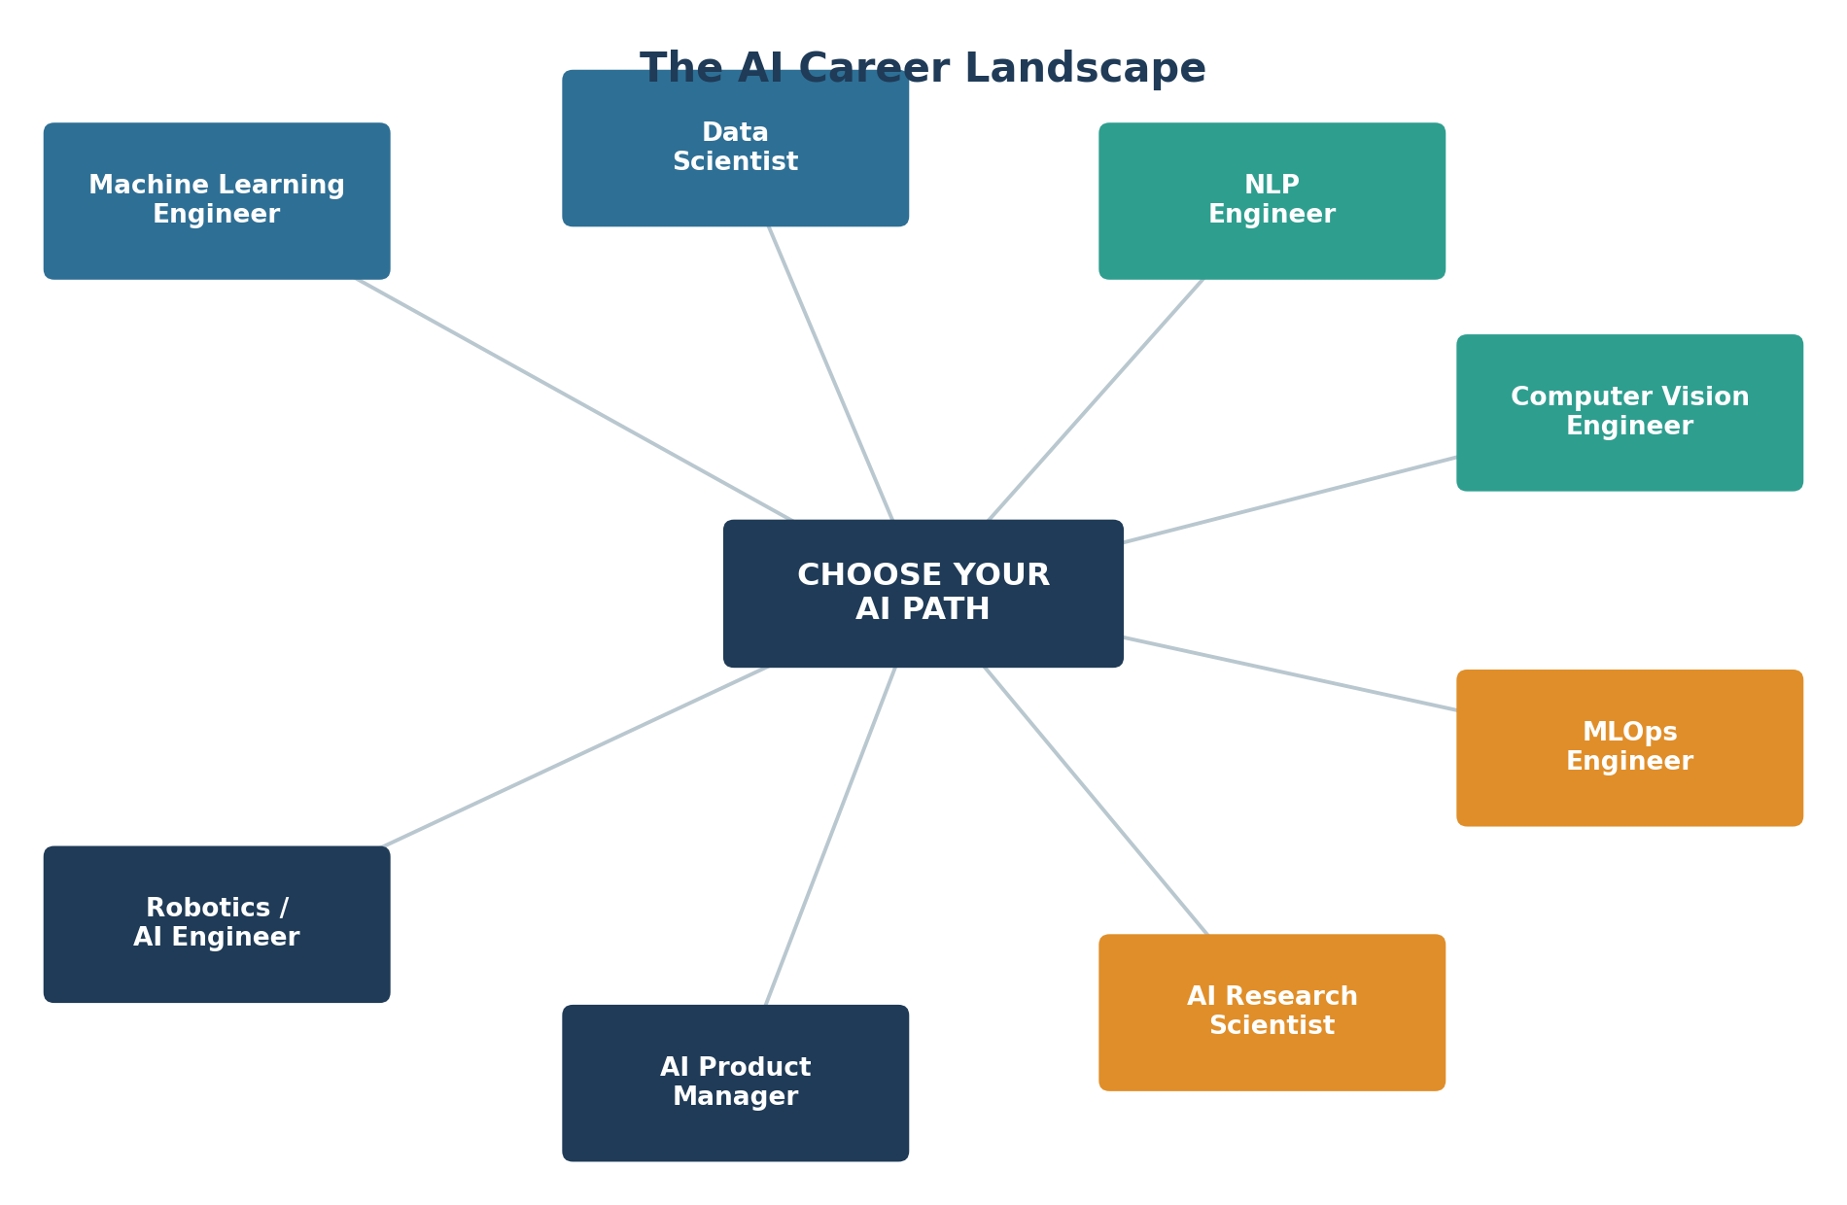
Figure 1: The AI Career Landscape — major specialisations branching from a common foundation.

2.1 Overview of Each Path
Path | Core Focus | Key Skills
Machine Learning Engineer | Designing & deploying predictive models | Python, scikit-learn, statistics, software engineering
Data Scientist | Extracting insights & patterns from data | Statistics, SQL, visualisation, storytelling
NLP Engineer | Teaching machines to understand language | Linguistics basics, transformers, PyTorch/TensorFlow
Computer Vision Engineer | Enabling machines to interpret images/video | OpenCV, CNNs, image processing
AI Research Scientist | Advancing theory & new algorithms | Linear algebra, calculus, research writing
MLOps Engineer | Productionising & scaling ML systems | Docker, cloud platforms, CI/CD pipelines
AI Product Manager | Bridging AI capability with business need | Communication, basic ML literacy, UX sense
Robotics / AI Engineer | Combining AI with physical systems | Control theory, embedded systems, reinforcement learning

3. Self-Assessment: Choosing Your Path
Before committing to a single specialisation, evaluate yourself honestly against three dimensions: mathematical comfort, programming confidence, and the type of problem that excites you. A simple way to think about this theoretically is through the ‘Interest – Aptitude – Demand’ (IAD) framework:
- Interest: Which AI applications do you naturally read about or experiment with in your free time — images, language, robots, numbers, or business strategy?
- Aptitude: Which subjects (linear algebra, statistics, DSA, or communication) come easiest to you right now?
- Demand: Which paths have strong internship and placement demand in the industry segment you want to enter (start-up, core tech, research, product company)?
You do not need to choose irreversibly. Most students explore two or three paths through small projects in their second year before specialising in the third year. The goal at this stage is informed exploration, not premature commitment.

4. Building a Powerful AI Portfolio
A portfolio is the tangible proof of your skills. Unlike a resume, which only claims competence, a portfolio demonstrates it. For AI specifically, a strong portfolio typically contains the following five elements:
- 1. Real Projects (not just tutorials): Pick a problem with a real dataset — e.g., predicting local weather, classifying regional languages, or detecting objects in traffic camera feeds. Original framing matters more than complexity.
- 2. Clean GitHub Repositories: Every project should have a clear README explaining the problem, approach, results, and how to run the code. This is often the first thing a recruiter or professor opens.
- 3. Competitive Practice: Platforms such as Kaggle, Zindi, or HackerRank AI tracks sharpen practical skills and provide benchmarkable achievements (e.g., ‘Top 15% in a Kaggle competition’).
- 4. Written Communication: A short blog post or LinkedIn article explaining what you built and why demonstrates the ability to communicate technical ideas — a skill many engineers lack.
- 5. Certifications (as supporting evidence only): Courses from recognised providers can validate foundational knowledge, but they should support your projects, not replace them.
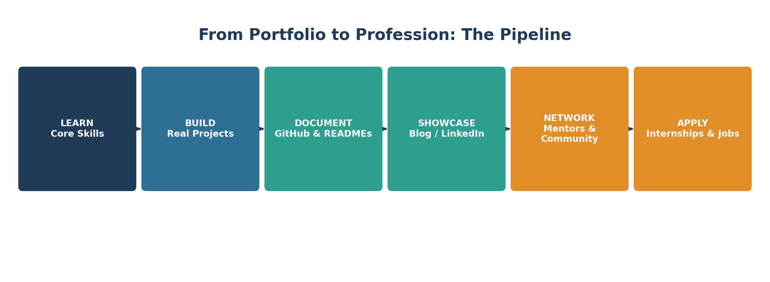
Figure 2: The Portfolio-Building Pipeline — from learning to employment.

5. Portfolio-to-Profession Roadmap
The transition from being a student to being a professional is gradual and works best when planned across your remaining years of study. The roadmap below gives a realistic, stage-wise plan starting from where you are now, in second year.
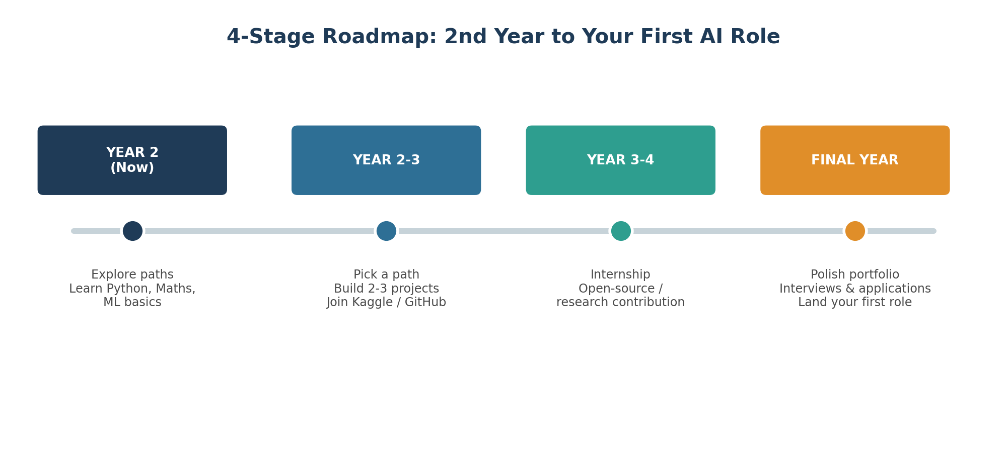
Figure 3: A 4-stage roadmap from second year to your first AI role.

5.1 Milestones to Track
- By end of Year 2: Complete one guided project and one self-designed mini-project in your chosen path.
- Early Year 3: Apply for a summer internship or research assistantship; contribute one pull request to an open-source AI project.
- Year 3: Build a flagship portfolio project that solves a real or local problem; present it at a college symposium or publish it as a blog.
- Final Year: Finalise resume and portfolio website; practise technical interviews (DSA + ML theory + project defence).

6. Interview & Job-Search Preparation
AI interviews usually test four areas: programming fundamentals (data structures and algorithms), mathematical reasoning (probability, linear algebra, optimisation), applied ML knowledge (model selection, evaluation metrics, overfitting), and the ability to explain your own portfolio projects clearly and honestly.
- Tip: Be ready to explain the weaknesses of your own projects. Interviewers often value honest reflection on a project's limitations more than a polished but shallow success story.
- Networking: Attend AI/ML meetups, college tech-fest talks, and LinkedIn communities. A large proportion of internships are discovered through informal networks rather than job portals alone.

7. Common Mistakes to Avoid
- Collecting certificates without building any original project.
- Copying tutorial projects without understanding or modifying the underlying logic.
- Switching your chosen path every few weeks instead of completing at least one meaningful project before deciding to pivot.
- Ignoring the ‘soft’ side — documentation, communication, and teamwork — which is equally important to employers.
- Waiting until the final year to start building a portfolio.

8. Conclusion
Choosing an AI career path is not a single decision made overnight — it is a gradual process of exploration, project-building, and reflection. Starting this process in your second year gives you a significant advantage: time. Use it to experiment broadly, then commit deliberately, and let your portfolio — not just your marksheet — tell your professional story.
Remember: profession follows portfolio. Build first; the job will follow.

9. Quick Reference: Where to Start
Category | Resources
Learn | NPTEL / Coursera / fast.ai / college ML course
Practice | Kaggle, HackerRank AI, LeetCode (DSA)
Build & Host Code | GitHub, GitHub Pages / a personal portfolio site
Showcase | LinkedIn articles, Medium, college tech blog
Network | College AI club, local ML meetups, LinkedIn groups

